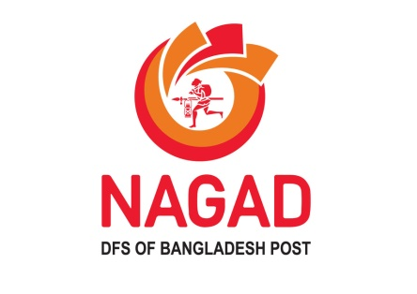

**Revolutionizing Digital Financial Services in Bangladesh**

Name: Mst. Fahmida Khatun

**Id No: 01-022-24**

**Batch: 22**

**Date: 4-9-2024**

INDEX

1. Executive summary: 3
2. Product and Service: 3
   1. HYPERLINK: 4
   2. SMART ART: 4
3. BUSINESS PLAN: 5
   1. Flow chart: 5
4. Sales and Cost Statistics: 6

# Executive summary:

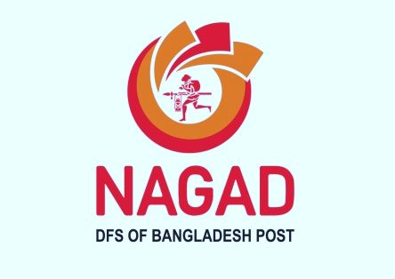NAGAD is poised to become an essential component of Bangladesh’s financial fabric. Aligned with the needs of the people and the development goals of the Bangladesh Government, NAGAD envisions its role as a one-stop digital banking destination in partnership with the entire financial services industry.

At NAGAD, we believe that strategic partnerships are the key to providing the people of Bangladesh with the most relevant and impactful digital financial services. We invite you to reimagine and leapfrog into the future of financial services alongside us.

Bangladesh is a thriving economic playground, pulsing with optimism and aspiration. A population of over 170 million people, nearly half of whom are under 25, has awakened to the vast possibilities of the future. They eagerly adopt new ideas from the outside while confidently forging their own path.

Under the innovative and century-old financial authority of the Bangladesh Post Office, NAGAD was launched on March 26, 2019, as a groundbreaking partnership. The mission is clear: to provide comprehensive, digital, and ever-evolving financial services to the country’s people and small businesses.

# Product and Service:

NAGAD offers a diverse range of financial services, such as person-to-person transfers, bill payments, and e-commerce payment options. The platform also enables users to save through its Nagad Savings product, providing a secure and efficient digital banking experience.

* **Mobile Wallet**: NAGAD allows users to open a mobile wallet directly linked to their phone numbers, enabling them to store money digitally and manage transactions easily.
* **Money Transfer**: Users can send and receive money instantly to other Nagad wallets or even to other bank accounts and MFS platforms within Bangladesh.
* **Bill Payments**: Nagad provides services for utility bill payments, such as electricity, gas, water, and internet bills, directly through its app or USSD service.
* **Mobile Recharge**: Customers can recharge their mobile phones from any telecom operator in Bangladesh through their Nagad wallet.
* **Merchant Payments**: Nagad enables users to pay for goods and services at various online and offline merchant outlets via QR codes or merchant numbers.
* **Government Services**: Nagad is involved in disbursing various government payments, subsidies, and social safety net allowances directly to beneficiaries’ mobile wallets, ensuring efficient and transparent distribution.
* **Cash In/Cash Out**: Customers can deposit (cash-in) and withdraw (cash-out) money through thousands of Nagad agents and partner banks across the country.
* **Savings and Financial Products**: Nagad offers savings schemes, allowing users to earn interest on their balances. They also provide micro-loan facilities in partnership with financial institutions.
* **International Remittance**: Nagad facilitates the receiving of international remittances, allowing families to receive funds from abroad securely and conveniently.

## HYPERLINK:

[OFFERS](https://nagad.com.bd/campaigns/)<mailto:fahmidalily9@gmail.com>

Some offers that available now

## SMART ART:

# BUSINESS PLAN:

## Flow chart:

**Security and Quick Process**

**Load money into Nagad Account**

**Perform transaction**

# Sales and Cost Statistics:

|  |  |  |
| --- | --- | --- |
| **Month** | **Transaction Volume (BDT)** | **New Customers** |
| January | 500,000,000 | 200,000 |
| February | 550,000,000 | 220,000 |
| March | 600,000,000 | 250,000 |